Steps to Convert FileDaSeleta Project to convert this back to Console Mode

1. Select Project : FileData > Property > tab “Application”
2. Update Output type to “Console Application”

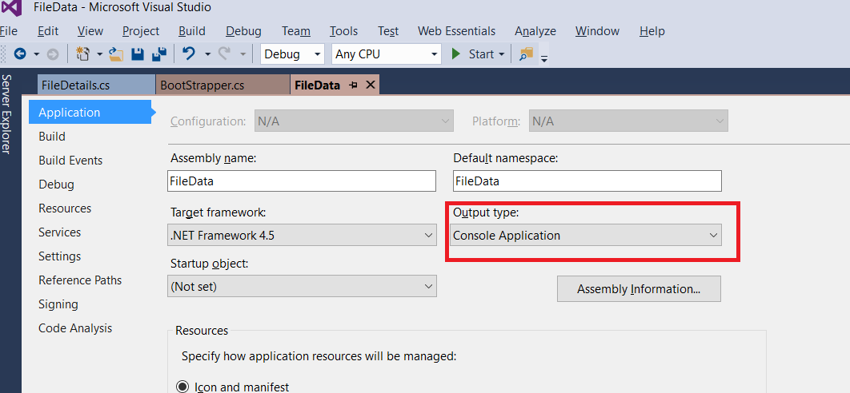

1. Save
2. IT should work normally